Customer Shopping Behavior Analysis
1. Project Overview:
This project analyzes customer shopping behavior using transactional retail data to understand spending patterns, customer segments, and product performance. The workflow involved cleaning and preparing data in Python, loading it into a relational database, and using SQL to answer business-focused questions around revenue, discounts, subscriptions, and customer loyalty. The goal was to replicate a real-world analytics process and generate insights that could support decisions related to pricing strategy, customer retention, and product positioning.

2. Dataset Summary:
- Rows: 3,900
- Columns: 18
- Key Features:
- Customer demographics (Age, Gender, Location, Subscription Status)
- Purchase details (Item Purchased, Category, Purchase Amount, Season, Size, Color)
- Shopping behavior (Discount Applied, Promo Code Used, Previous Purchases, Frequency of Purchases, Review Rating, Shipping Type)
- Missing Data: 37 values in Review Rating column

3. Exploratory Data Analysis using Python
We began with data preparation and cleaning in Python:
● Data Loading: Imported the dataset using pandas.
● Initial Exploration: Used df.info() to check structure and .describe() for summary statistics.
● Missing Data Handling: Checked for null values and imputed missing values in the Review Rating column using the median rating of each product category.
● Column Standardization: Renamed columns to snake case for better readability and documentation.
● Feature Engineering:
○ Created age_group column by binning customer ages.
○ Created purchase_frequency_days column from purchase data.
● Data Consistency Check: Verified if discount_applied and promo_code_used were redundant; dropped promo_code_used.
● Database Integration: Connected Python script to MySQL and loaded the cleaned DataFrame into the database for SQL analysis.

4. Data Analysis using SQL (Business Transactions)
- What is the total revenue generated by male vs. female customers?
gender | revenue
Male | 157890
Female | 75191

- Which customers used a discount but still spent more than the average purchase amount?
customer_id | purchase_amount
2 | 64
3 | 73
4 | 90
7 | 85
9 | 97
12 | 68
13 | 72
16 | 81
20 | 90
22 | 62

- Which are the top 5 products with the highest average review rating?
item_purchased | avg_review_rating
Gloves | 3.86
Sandals | 3.84
Boots | 3.82
Hat | 3.8
Skirt | 3.78

- Compare the average purchase amounts between Standard and Express shipping.
shipping_type | Avg_purchase_amount
Express | 60.48
Standard | 58.46

- Do subscribed customers spend more? Compare average spend and total revenue between subscribers and non-subscribers.
subscription_status | total_cus | avg_spend | revenue_generated
Yes | 1053 | 59.4919 | 62645
No | 2847 | 59.8651 | 170436

- Which 5 products have the highest percentage of purchases with discounts applied?
item | discount_rate
Hat | 50
Sneakers | 49.66
Coat | 49.07
Sweater | 48.17
Pants | 47.37

- Segment customers into New, Returning, and Loyal based on their total number of previous purchases, and show the count of each segment.
cust_segment | no_of_cust
Loyal | 3116
Returning | 701
New | 83

- What are the top 3 most purchased products within each category?
rank | category | item_purchased | count_cust
1 | Accessories | Jewelry | 171
2 | Accessories | Sunglasses | 161
3 | Accessories | Belt | 161
1 | Clothing | Blouse | 171
2 | Clothing | Pants | 171
3 | Clothing | Shirt | 169
s1 | Footwear | Sandals | 160
2 | Footwear | Shoes | 150
3 | Footwear | Sneakers | 145
1 | Outerwear | Jacket | 163
2 | Outerwear | Coat | 161

- Are customers who are repeat buyers (more than 5 previous purchases) also likely to subscribe?
subscription_status | repeat_buyers
Yes | 958
No | 2518

- What is the revenue contribution of each age group?
age_category | revenue
Young Adult | 62143
Middle Age | 59197
Adult | 55978
Senior | 55763

5. Dashboard in Power BI:
Finally, we built an interactive dashboard in Power BI to present insights visually
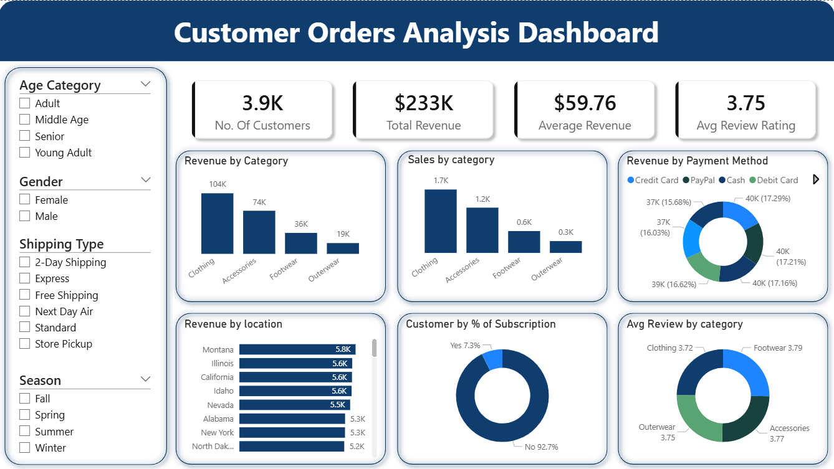
6. Business Recommendations:
● Boost Subscriptions – Promote exclusive benefits for subscribers.
● Customer Loyalty Programs – Reward repeat buyers to move them into the “Loyal” segment.
● Review Discount Policy – Balance sales boosts with margin control.
● Product Positioning – Highlight top-rated and best-selling products in campaigns.
● Targeted Marketing – Focus efforts on high-revenue age groups and express-shipping users.

